**Scripting Dynamic Forms in Polaris System**

Core files that need to be edited:

* IntegrationObject.sql
* IntegrationObjectField.sql
* IntegrationObjectLocaleText.sql

Files that need to be edited for dropdown/multiselect controls

* UserFormControlType.sql
* UserFormLookUp.sql
* Fit.Core/Domain/Components/ComponentKey.cs
* Fit.Services/Domain/Components/DropDownComponentService.cs
* Fit.Services/Domain/Components/FormBuilder/Enums/FormControlTypeEnum.cs

For reference: **For-profit board position form**

* [User Story](https://pwc-gx-humancapital.visualstudio.com/Polaris/_workitems/edit/193326/)
* [Pull Request](https://pwc-gx-humancapital.visualstudio.com/Polaris/_git/Polaris/pullrequest/14272?path=%2FFIT.Database%2FPostDeploymentScripts%2FFY21%2FClearanceForms%2FForProfitBoardPosition.sql&_a=files)

**Step 1: Update IntegrationObjectLocaleText.sql**

1. The first line you want to add is the formKeyCode for you new form
2. If any dropdown/multiselect controls, add each option for each control
3. Enter *IntegrationObjectFieldKey*

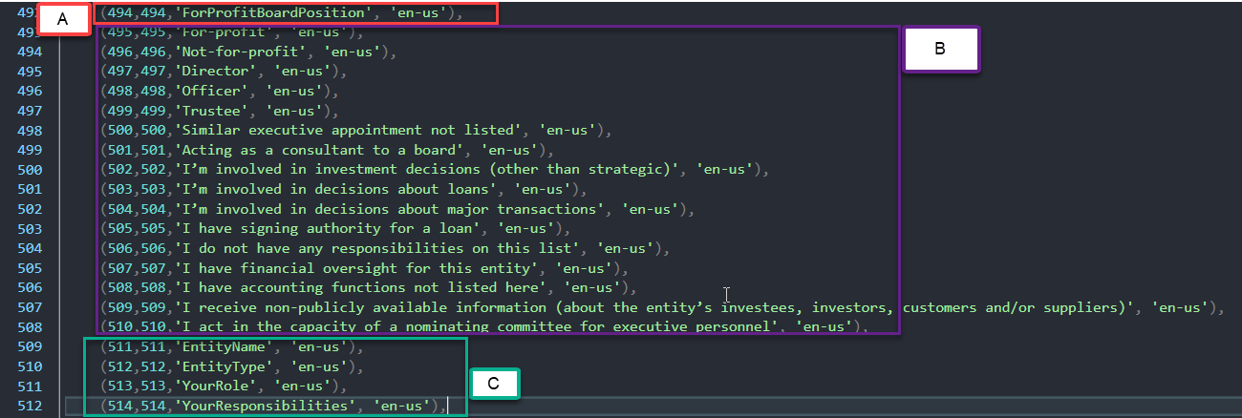

**Step 2: Update IntegrationObject.sql**

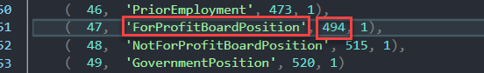

Note: Values should match those entered in **Step 1-A** from *IntegrationObjectLocaleText.sql*

**IF dropdowns and multiselect controls present follow Step 3, otherwise skip to Step 4**

**Step 3a: Update UserFormControlType.sql**

Foreach dropdown and multiselect control enter a new record.

1. Control type
2. DataSource (Enter name relevant to dropdown/multiselect question)

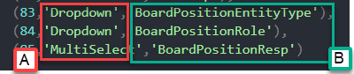

**Step 3b: Update UserFormLookUp.sql**

Map each dropdown/multiselect value to respective control

1. *IntegrationObjectLocaleTextID* set in **Step 1-B**
2. DataSource set in **Step 3a-A**

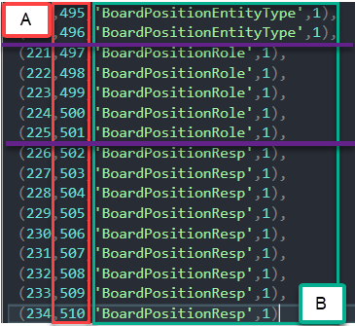

*Note: Purple line separating each dropdown/multiselect control*

**Step 3c: Update Fit.Core/Domain/Components/ComponentKey.cs**

Enter the DataSource values from **Step 3a-B**

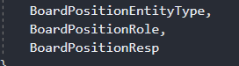

**Step 3d: Update Fit.Services/Domain/Components/DropDownComponentService.cs**

Enter new cases for each dropdown/multiselect in the new form. Parameter should be the new ComponentKeys set in **Step 3c**

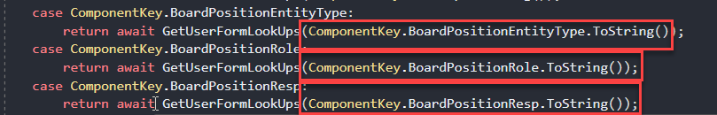

**Step 3e: Update Fit.Services/Domain/Components/FormBuilder/Enums/FormControlTypeEnum.cs**

Datasource_ + {DataSource set in **Step 3a-B**}

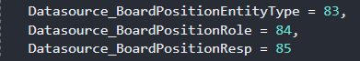

**Step 4: Update IntegrationObjectField.sql**

1. *IntegrationObjectID* from **Step 2**
2. DataType
3. *IntegrationObjectFieldKey* from **Step 1-C**
4. *IntegrationObjectFieldDisplayNameContentID* from **Step 1-C**
5. 1 = IsRequired and 0 = IsNotRequried
6. 1 = IsReadOnly and 0 = IsNotReadOnly
7. Full question label
8. UserFormControlType
   1. Common Control Types
      1. 2 = Calendar
      2. 34 = Textbox
      3. 32 = TextArea
   2. For dropdowns/multiselects enter values set in **Step 3a**

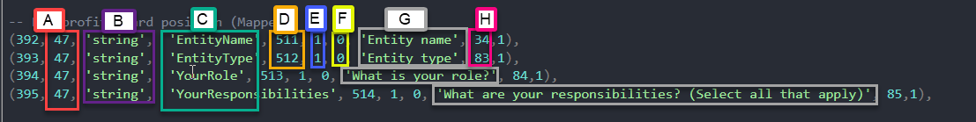

**Step 5: Create new PostDeployScript for form.**

This will do all of the necessary inserts for defaulting the new form template.

Most information needed is provided in **Step 4.**

This is also where help text is set.

Please refer to *ForProfitBoardPosition.sql* as an example.

**Step 6: Adding new script to PostDeploy.sql.**

